**UI SPECIFICATIONS**

The basic UI features will complement the map overlay present at all times. Spread over the map are various icons. These represent different types of posts based on the icon.

* Camera icon represents a photo taken by a user at that location. Clicking on this icon will bring the photo to the forefront of the screen with the map dimmed. At the bottom of the photo, the user’s caption (if one exists) and name will be displayed. This will be placed in a dimmed transparent background, shown in the second image below.
* Camera plus icon represents multiple photos taken at that location. Clicking on this icon will bring up the newest photo taken at this location. There will be arrows on either side of the photo to scroll through other photos. This may be multiple photos from the same user or photos from different users all taken at the same location.
* Chat icon represent a group chat. Clicking on this icon will bring up a group chat with users who are in the same location or have recently posted photos in that location.

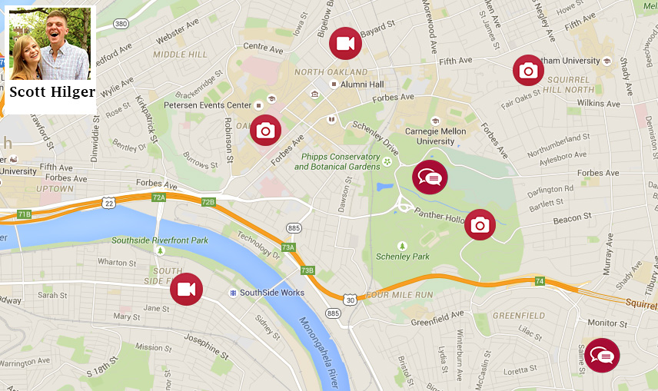

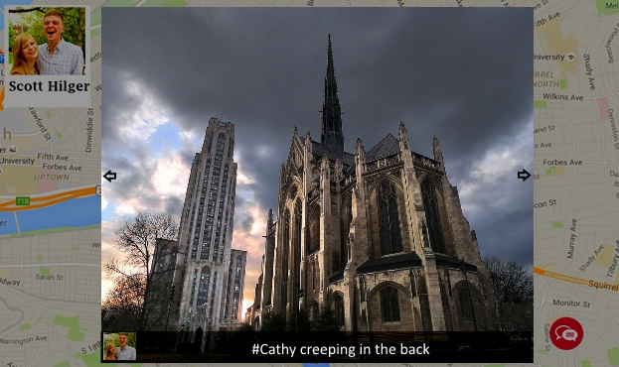

At the top of the page, there is a navigation bar. This bar has various features like search.

At all times, the user’s profile is at the top left corner. This consists of the user’s name and profile picture. The profile can be moved to the navigation bar if necessary. Clicking on the profile will bring up a profile settings menu.